**DELIVERY BOOKING SYSTEM- FINAL PROJECT**

**OUTPUT SCREENSHOTS**

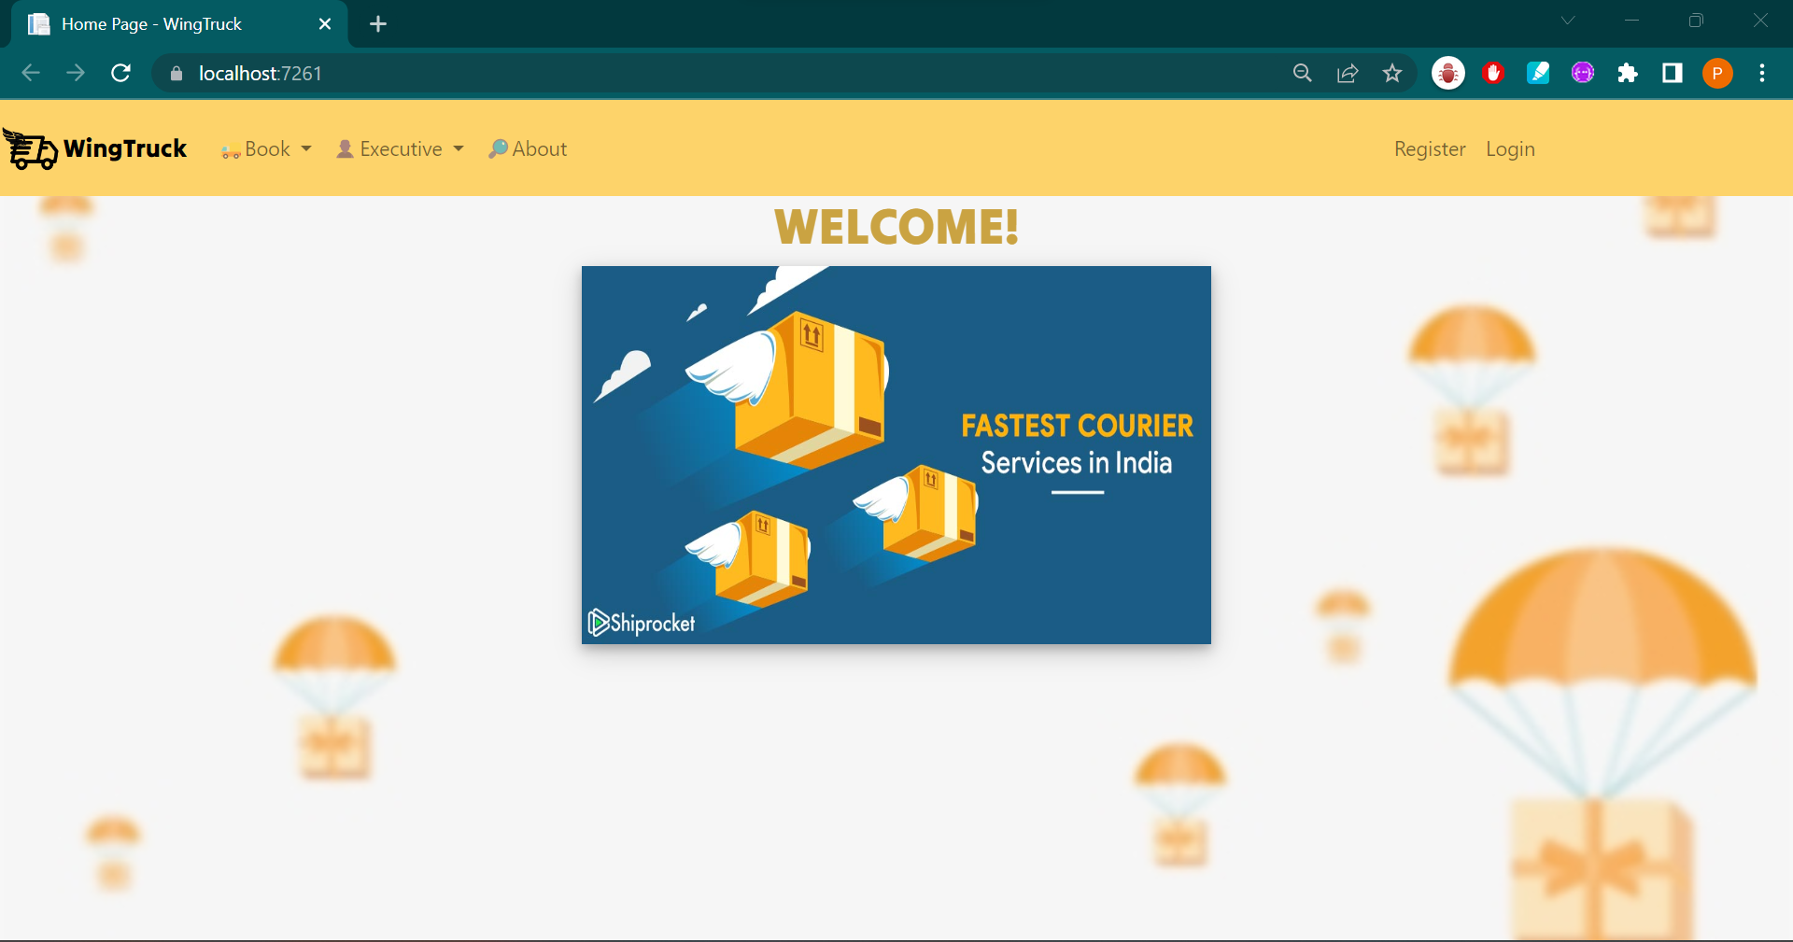

**CUSTOMER**

NEW BOOKING :

VIEW SERVICES :

VIEW ORDER TYPES

**EXECUTIVE**

ACCEPT REQUEST

DECLINE ORDER

